Create a simple cloud software application and provide it as a service using
any Cloud Service Provider to demonstrate Software as a Service (SaaS).

Aim :

Create a simple cloud software application and provide it as a service using any Cloud Service Provider to demonstrate Software as a Service (SaaS).

Procedure :

- Created a Zoho account and logged in to Zoho Creator.
- Created a new application named Cloud Task Manager.
- Designed a form (Task_Form) with fields: Task Name, Description, Due Date, and Status.
- Configured the Status field as a dropdown with values Pending and Completed.
- Created reports to view and manage task records stored in the cloud.
- Implemented a workflow triggered on successful form submission.
- Added a Deluge script in the workflow to automatically set the task status to Pending.
- Deployed the application on Zoho Cloud and accessed it through a web browser using the generated URL.
- Tested the application by adding tasks and verifying automatic status assignment and data storage.

Output :

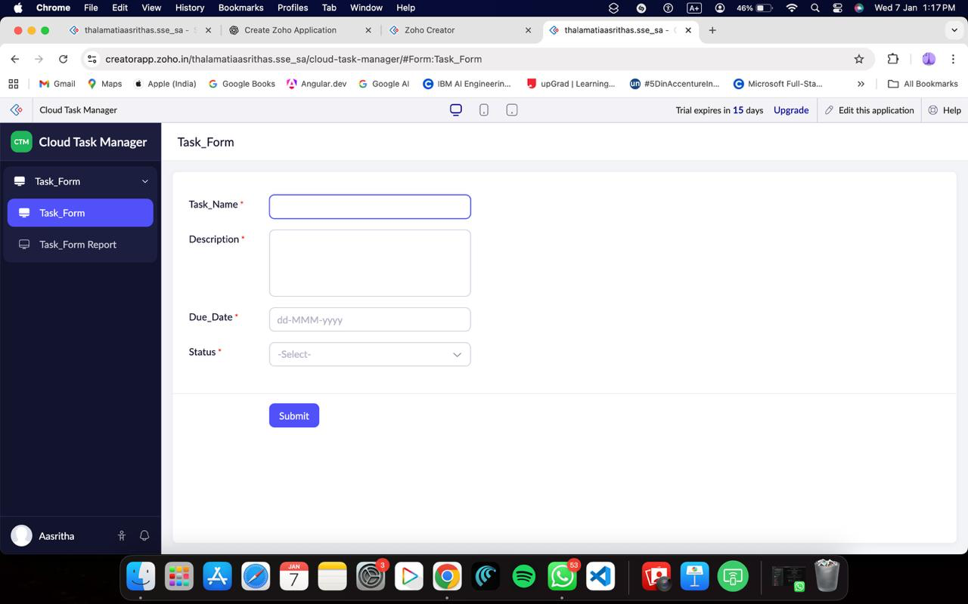
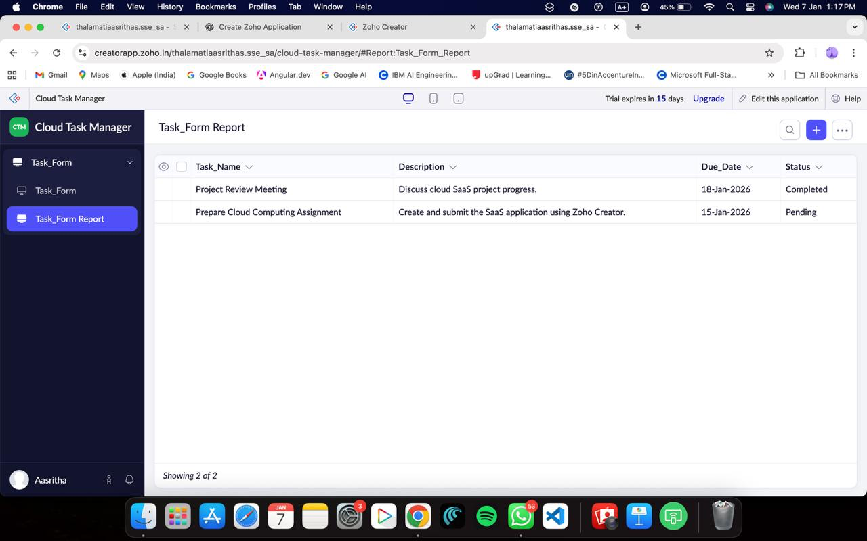

Result :

A cloud-based Task Management application was successfully created and deployed using Zoho Creator. The application was accessed through a web browser without any local installation. Tasks were stored and managed in the cloud, and workflow automation was verified. Thus, the Software as a Service (SaaS) model was successfully demonstrated.

